LAB EXPERIMENT

SET 15: PRODUCT SALES ANALYSIS

Department | AIDS
Course Code / Course Name | DSA0602 / Data Handling and Visualization
Experiment | Data Visualization using R and Tableau
Name | D.HEMASREE
Register Number | 192524114
Date | 8 October 2026
Day | Thursday

Aim
To analyze monthly product sales data using a grouped bar chart, a stacked area chart and a sales table in R, and to build an interactive dashboard using Tableau. Dataset: Monthly Product Sales

Product ID | Product Name | January Sales | February Sales | March Sales
1 | Product A | 2000 | 2200 | 2400
2 | Product B | 1500 | 1800 | 1600
3 | Product C | 1200 | 1400 | 1100

PROGRAM 1: Grouped Bar Chart of Quarterly Sales
Create a grouped bar chart to visualize the sales of each product for the first quarter. Label the chart elements.
# Dataset (rows = months, columns = products) sales_matrix <- rbind(
January = c(2000, 1500, 1200),
February = c(2200, 1800, 1400),
March = c(2400, 1600, 1100)
)
colnames(sales_matrix) <- c("Product A", "Product B", "Product C")

# Grouped Bar Chart barplot(sales_matrix,
beside = TRUE,
col = c("steelblue", "darkorange", "forestgreen"), xlab = "Product",
ylab = "Sales",
main = "Quarter 1 Sales by Product", legend.text = rownames(sales_matrix),
args.legend = list(x = "topright", title = "Month"), ylim = c(0, 3000))

OUTPUT:
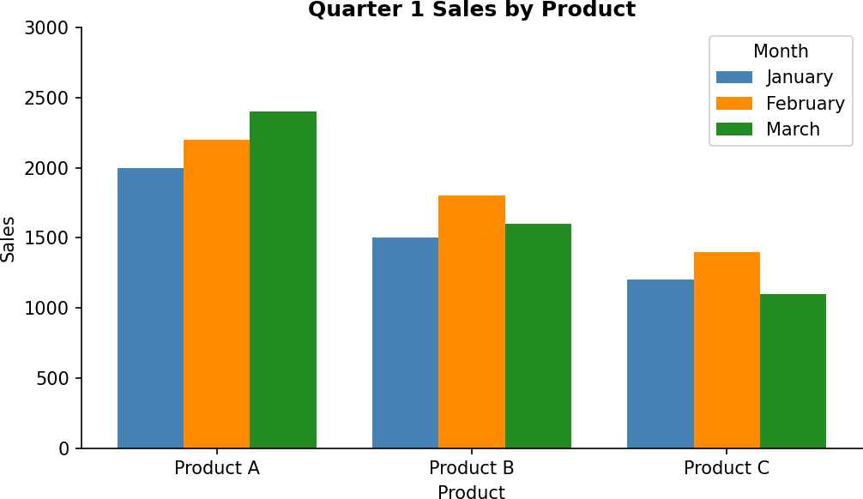

Output 1: Quarter 1 Sales by Product (Grouped Bar Chart)

Observation:
Product A has the highest sales in every month and grows steadily from 2,000 in January to 2,400 in March. Products B and C both rise in February but fall in March (B to 1,600 and C to 1,100). Product C has the lowest sales overall, with its March value of 1,100 being the lowest figure in the dataset.

PROGRAM 2: Stacked Area Chart of Overall Sales Trend
Generate a stacked area chart to represent the overall sales trend for all products over the three months.
library(ggplot2)

# Dataset in long format long_sales <- data.frame(
month = rep(1:3, times = 3),
product = rep(c("Product A", "Product B", "Product C"), each = 3),
# Stacked Area Chart
ggplot(long_sales, aes(x = month, y = sales, fill = product)) + geom_area() +
scale_x_continuous(breaks = 1:3,
labels = c("January", "February", "March")) + labs(title = "Overall Sales Trend - First Quarter",
x = "Month", y = "Sales",
fill = "Product")

sales | = | c(2000, | 2200, | 2400,
 |  | 1500, | 1800, | 1600,
 |  | 1200, | 1400, | 1100)
)

OUTPUT:
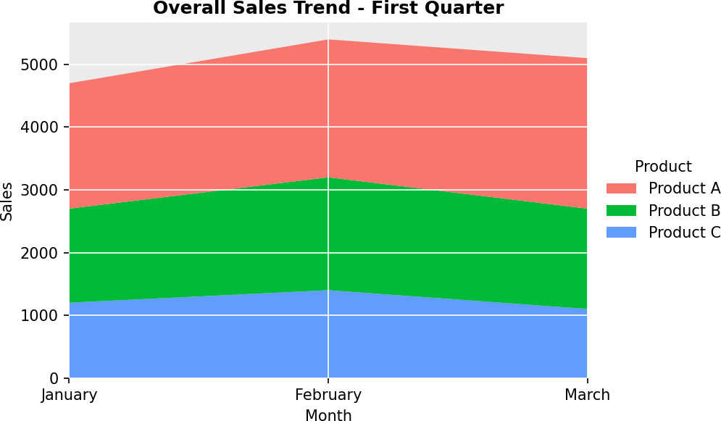

Output 2: Overall Sales Trend (Stacked Area Chart)

Observation:
The total sales of all products increase from 4,700 in January to 5,400 in February (about 15%) and then fall to 5,100 in March (about 6%). February is the best month overall. Product A forms the largest layer of the area, about 43% of the quarter's total sales of 15,200, followed by Product B (about 32%) and Product C (about 24%).

PROGRAM 3: Table of Monthly Sales for Each Product
Build a table to show the monthly sales data for each product. Label the table elements.
# Dataset
sales <- data.frame( Product_ID = 1:3,
Product_Name = c("Product A", "Product B", "Product C"),
# Add a total column for the quarter
sales$Total <- sales$January + sales$February + sales$March

# Display the table print(sales)

# Monthly totals across all products
colSums(sales[, c("January", "February", "March", "Total")])

January | = | c(2000, | 1500, | 1200),
February | = | c(2200, | 1800, | 1400),
March | = | c(2400, | 1600, | 1100)
)

OUTPUT:
Product_ID Product_Name January February March Total
1 1 Product A 2000 2200 2400 6600

2 | 2 | Product B | 1500 | 1800 1600 4900
3 | 3 | Product C | 1200 | 1400 1100 3700
January | February | March | Total
4700 | 5400 | 5100 | 15200
Output 3a: Monthly Product Sales Table (R Console)

Product Name | January | February | March | Total
Product A | 2000 | 2200 | 2400 | 6600
Product B | 1500 | 1800 | 1600 | 4900
Product C | 1200 | 1400 | 1100 | 3700
Total | 4700 | 5400 | 5100 | 15200
Output 3b: Monthly Sales Table with Totals

Observation:
The table gives the exact sales of each product in each month. Product A has the highest quarterly total (6,600), then Product B (4,900) and Product C (3,700). The monthly totals show that February (5,400) was the strongest month and January (4,700) the weakest.

PROGRAM 4: Interactive Product Sales Dashboard in Tableau
Develop a Tableau dashboard combining the grouped bar chart, stacked area chart and the table for interactive exploration of sales data.

Steps in Tableau
- Save the data as an Excel or CSV file and connect to it in Tableau (Connect > Microsoft Excel / Text file). Select the January Sales, February Sales and March Sales columns, right-click and choose Pivot, then rename the new fields to "Month" and "Sales".
- Sheet 1 (Grouped Bar Chart): Drag Product Name and then Month to Columns, and Sales to Rows (SUM). Drag Month to Color and add Sales to Label. Rename the sheet "Sales by Product".
- Sheet 2 (Stacked Area Chart): Drag Month to Columns and Sales to Rows (SUM). Change the Marks type to Area, drag Product Name to Color, and rename the sheet "Sales Trend".
- Sheet 3 (Table): Drag Product Name to Rows, Month to Columns and Sales to Text. Use Analysis
  - Totals > Show Row Grand Totals and Show Column Grand Totals. Rename the sheet "Sales Table".
- Create a new Dashboard (Dashboard > New Dashboard), set the size to Automatic, and drag the three sheets onto the dashboard area.
- Add interactivity: select each chart and click Use as Filter, so clicking a product or month in one view filters the others. Add Product Name and Month filters (Show Filter > Apply to Worksheets
  - All Using This Data Source).
- Add the title "Product Sales Dashboard" and test the filters in Presentation Mode.

OUTPUT:
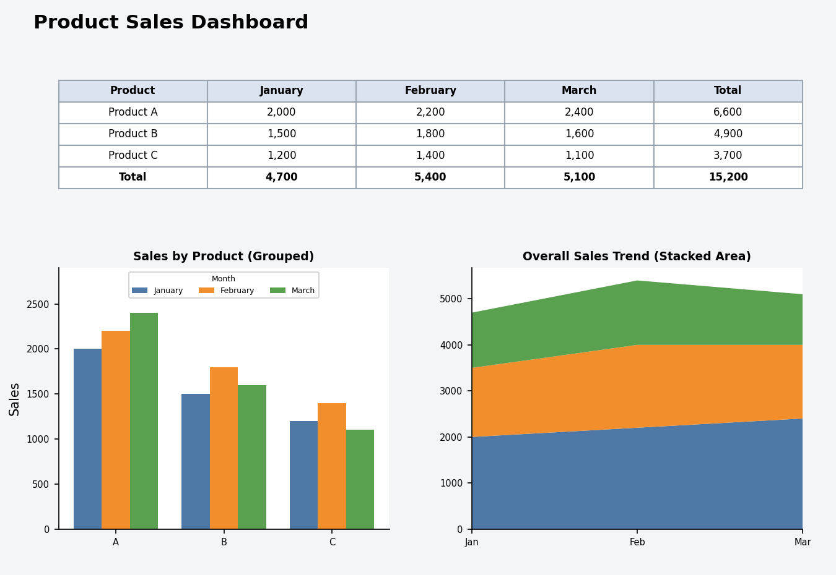
Output 4: Interactive Product Sales Dashboard (Tableau)

Observation:
The dashboard shows the product comparison, the overall sales trend and the sales table together.

Procedure
- Define the sales values for each product and month in R as a matrix and a data frame.
- Use barplot() with beside = TRUE to create the grouped bar chart of first quarter sales.
- Arrange the data in long format and use ggplot2 with geom_area() to draw the stacked area chart.
- Create a data frame of the monthly sales, add a Total column, and display it with print() and colSums().
- Load the sales file into Tableau, pivot the month columns, and build the grouped bar chart, stacked area chart and table worksheets.
- Combine the worksheets in a Tableau dashboard and add filters and actions for interactivity.

RESULT:
The monthly product sales data was successfully analyzed using a grouped bar chart, a stacked area chart and a sales table in R. An interactive Tableau dashboard was also created, combining all three views so that users can explore the sales data by product and by month.

Key Functions and Tools Used

Function / Tool | Purpose
rbind() / data.frame() | Creates the sales matrix and the sales table.
barplot(beside = TRUE) | Creates the grouped bar chart.

Function / Tool | Purpose
ggplot() / geom_area() | Creates the stacked area chart.
print() / colSums() | Displays the sales table and calculates monthly totals.
Tableau Pivot | Converts the month columns into Month and Sales fields.
Tableau Dashboard | Combines worksheets with filters and actions.

